Biomedical engineering
lesson plan

Adaptable for Grades 6-8
Can be adapted for two 90-minute plans or four 45-minute plans

Biomaterials
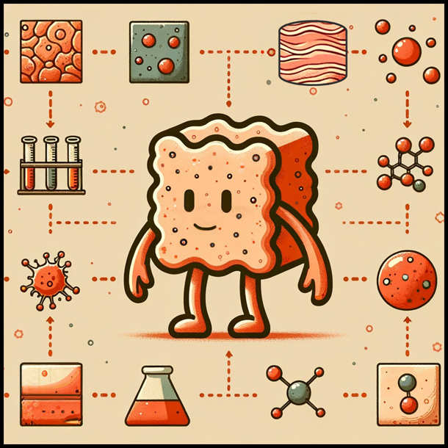

Developed by Katy Lydon
National Institute of Biomedical Imaging and Bioengineering
BEAMS Challenge
BEAMS Lesson Plan Disclaimer

This lesson plan and materials were created by participants who submitted materials in response to the NIBIB Bioengineering Adapted for Middle School (BEAMS) Challenge. Every attempt has been made to verify the accuracy of the content. The external links to nonfederal websites included in these materials provide additional information and resources. NIBIB cannot attest to the accuracy or accessibility of a nonfederal site. The statements, opinions or conclusions contained in these materials do not necessarily represent the statements, opinions or conclusions of the NIH, its component institutes and centers, or the United States government. These materials are in the public domain and may be used and adapted freely.

Some images may only be used in these materials and not for other purposes. Please see our copyright policy for further information.

Table of Contents
Lesson 1: What are biomaterials? 1
Sorting Activity 5
Sorting Activity Description: 6
Sorting Activity Rubric 7
Lesson 2: Properties of Biomaterials and Applications of Biomaterials in the Medical Field 8
Jigsaw Activity Description: 12
Role cards for groups of 3 13
Lesson 3: Jigsaw Day 2 + Start of Engineering Challenge 16
Jigsaw Presentation Rubric 19
Engineering Challenge Description: 20
Lesson 4: Applications of Biomaterials and Engineering Challenge Day 21
Constraints and Criteria: 24
Engineering Challenge: 25
Engineering Challenge Presentation Rubric 26
Resources for Ceramics: 27
Advantages and Disadvantages of Ceramics 27
Biocompatibility of Ceramics 29
Applications of Ceramics in the Medical Field 30
Environmental Impact of Ceramics 32
Additional Resources for Material Properties of Ceramics 33
Resources for Metals: 34
Advantages of Metals 34
Disadvantages of Metals 36
Biocompatibility of Metals 37
Applications of Metals in the Medical Field 38
Environmental Impact of Metals 40
Material Properties of Metals 41
Resources for Polymers: 42
Advantages of Polymers 42
Disadvantages of Polymers 43
Biocompatibility of Polymers 44
Applications of Polymers in the Medical Field 45
Environmental Impact of Polymers 47
Additional Polymer Resources 48

Lesson Title  Lesson # | Lesson 1: What are biomaterials?
Grade Level | Middle School |  | Length of Lesson Time: | 45 minutes
Academic Standards | MS-PS1-3: Students who demonstrate understanding can: Gather and make sense of information to describe that synthetic materials come from natural resources and impact society.
Lesson Objectives | The learner will be able to (TLWBAT):  - Identify the major types of biomaterials  The learner will know (TLWK):  - The major types of biomaterials used in the medical field (ceramics, metals, polymers, hydrogels, natural)  - The sources of biomaterials  - How to sort materials based on their properties  - The possible applications for biomaterials within the medical field.
Language | Academic Language | Science Language |  | Language Production Strategies
 | Observe, compare, discuss, defend | Biomaterial, ceramic, polymer, metal, composite, hydrogel, natural material, scaffold, implant. |  | - Small group discussions  - Presenting and answering questions about material sorting  - Presentation Q/A  - Self-evaluation forms  - Peer-evaluation forms
Resources | Materials & Technology | Documents & Handouts |  | Volunteers
 | Mini Lecture Slides Sorting Hat Description Sorting Hat Rubric | Mini Lecture Handout for Students Sorting Hat Handout |  | A biomaterials specialist could provide biomaterial examples for the sorting activity (hip replacement, dental implants) specific biomaterials questions.  Can be run very well without any volunteers.
Essential | - Learner engages in scientifically oriented questions

Features of Inquiry | - Learner gives priority to evidence in responding to questions  - Learner formulates explanations from evidence  - Learner communicates and justifies explanations
Instructional Plan | Teacher Talk/Action | Student Talk/Action | Teaching Strategy/ Rationale Essential Feature of Inquiry
Class plan:
20 min Sorting Hat
 | 20 min mini lecture
 | 5 minute Engineering Challenge Introduction
 | - Sorting Hat  - Teacher introduces sorting hat activity to students, and splits class into small groups (3-4 students per group, split class by counting off students).  - Teacher will pass out the four category cards/labels to each group.  - Teacher will explain that they now need to read the definitions on the category cards. They will assign a category to each of the groups they’ve already sorted the materials into and make adjustments as needed.  - Following each “defense” the teacher will ask each group (the non-presenters) questions to engage the rest of the group in the discussion. | - Sorting Hat  - Students will engage in sorting hat activity.  - Students will observe and evaluate the materials they have been provided.  - Without the 4 category cards, students will sort the materials into 4 groups based on their observations and senses.  - With the category cards now given to the students, they will adjust their sorting based on what they think needs to go into each of those groups given the name and definition (ceramics, metals, polymers, composites)  - Each group will defend their sorting/reasons one by one. | Learner formulates explanations from evidence  - Observe biomaterials and determine which group they fit into  Learner communicates and justifies explanations  - Defend materials sorting  Learner engages in scientifically oriented questions and learner gives priority to evidence when responding to questions  - Answers questions posed by the teacher to further explain sorting choices

 | - Mini Lesson  - After the presentations are done, the teacher will tell the students that the materials they’ve been working with are all considered biomaterials. This will begin a mini-lecture on what biomaterials are to fill in gaps in knowledge. The presentation will include what is a biomaterial, the various biomaterials that exist, their uses in medicine.  - The teacher will engage the students by asking questions as they go through the powerpoint.  - “What do you think makes a material a biomaterial?”  - “What potential uses do you think biomaterials have in medicine?”  - Introduction to Engineering Challenge:  - Teacher will introduce to the students that Lesson 4 will be an engineering day, in which students will be constructing a product to solve a medical issue.  - The teacher will ask the students to think of a medical issue or condition that they have a connection to or are interested in.  - The teacher will count the votes and announce the winning condition at the end of the 3rd lesson. | - Mini Lesson  - Students will follow along in the presentation by filling in the blanks in their handout.  - Students will engage with the teacher as the teacher asks questions throughout the presentation.  - Introduction to Engineering Challenge:  - Students will write down the conditions on a piece of paper, fold it up and give it to the teacher. | Learner engages in scientifically oriented questions  - Throughout the lecture, students will answer questions posed by the teacher

Assessment | Presentation/answering questions

Sorting Activity

Your Task: New materials are joining The New School of Biomaterials and need to be sorted into their corresponding teams. Use your senses to determine as a group which team each material should be sorted into.

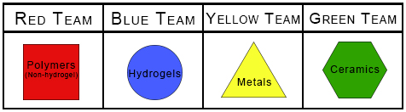

Once your group has come to a decision, choose one person that will explain and defend why your group decided to sort the materials as you did. All other members of the group will be responsible for answering questions.

Question to discuss with group:
- How did you sort the materials into groups?
- Did you need to make many changes to your groups once provided with the teams?
- What are some similarities between materials in each group?

Sorting Activity Description:

Purpose: The purpose of this activity is to engage the students in a hands-on group activity that will end with each group defending their sorting techniques and reasons to the class. The goal of this activity is to introduce students to the various types of biomaterials and letting them discover their properties by feeling and working with them. This activity will lead into a
mini-lecture on “What are Biomaterials?”.

How to run this activity:
- Students will be given a box of materials, this will include items such as:
  - Metals: coins, soda can, spoon, etc.
  - Polymers: sutures, tubing, PVC pipe, plastic bottle, rubber band, silk, etc.
  - Ceramics: ceramic bowl, brick, dental implants, etc.
  - Hydrogels: gelatin, orbeez, etc.
- Students will be given 5-10 minutes to sort the biomaterials into four groups without having any categories defined.
- Teacher will then pass out the categories/team cards to the students.
- Students will be given 5-10 minutes to assign teams to the groups of biomaterials they’ve created, and make adjustments to their sorting as needed, and develop a reasoning for why they sorted them the way they did.
- At the end of the 10 minutes students will defend their sorting.
  - Groups will go one at a time
  - One person will present for each group
  - They will explain how they decided to sort the materials and what materials ended up in what houses.
  - Teacher will ask the non-presenting students questions to have them participate and conduct language production. These questions will include things like: “What commonalities did you notice between the materials you sorted into blank group?”, “What is a property of blank material?”, etc.

Sorting Activity Rubric

Student Name:

Scientiﬁc Discourse | Partially Meets (1) | Meets (3) | Exceeds (5)
Language Production | - Student (defending or answering questions) uses non-scientific language to provide an explanation/answer. | - Student (defending or answering questions) uses new language to provide an explanation/answer. | - Student (defending or answering questions) uses scientific language and knowledge to provide an explanation/answer.
Participation | - Student somewhat engages with the group during the sorting activity. | - Student engages with the group during the sorting activity.  - Student defends or answers questions from the teacher. | - Student takes a leading role in the group discussion and sorting activity.  - Student listens to all group members ideas.
Demonstrates Understanding | - Students shows little understanding of how and why the group sorted the materials into the corresponding categories. | - Student shows some understanding of how and why the group sorted the materials into the corresponding categories. | - Student defends or answers question from teacher with clear understanding of how and why the group sorted the materials into the corresponding categories.

Lesson Title  Lesson # | Lesson 2: Properties of Biomaterials and Applications of Biomaterials in the Medical Field
Grade Level | Middle School |  | Length of Lesson Time: | 45 Minutes
Academic Standards/ CCF | These lessons are primarily focused on the mastery of MS-ETS1-1 and MS-PS1-3, however, Lesson 2 touches on the NGSS practice of Obtaining, Evaluating and Communicating Information. Students will use provided resources to obtain and evaluate information that will then be added to a presentation and communicated to the class during the reversed classroom Jigsaw activity.
Lesson Objectives | The learner will be able to (TLWBAT):  - The learner will be able to research a given question and material  - The learner will be able to interpret and summarize their scientific findings and develop a concise presentation  - The learner will be able to work with their assigned group in creating the presentation  The learner will know (TLWK):  - The learner will know the major properties of the assigned biomaterial (ceramics, metals, polymers, hydrogels)  - The learner will know the major advantages of the assigned biomaterial  - The learner will know the major disadvantages of the assigned biomaterial  - The learner will know the major applications and uses of the assigned biomaterial in the medical field  - The learner will know the major sources of the assigned biomaterial and their impact on the environment
Language | Academic Language | Science Language |  | Language Production Strategies
 | Discuss, research, compile information, create presentations, present findings, answer questions. | Ceramics, metals, polymers, hydrogels, mechanical properties, bulk properties, surface properties |  | Small group discussions  Presenting their findings in front of the class  Answering questions from other students and the teacher  Answering Jeopardy style questions
Resources | Materials & Technology | Documents & Handouts |  | Volunteers
 | Description of Jigsaw Activity Jigsaw Presentation Rubric | Ceramic Resources Metal Resources Polymer Resources  Role Cards for Jigsaw Activity |  | Can be run very well without any volunteers

Essential Features of Inquiry | - Learner engages in scientifically oriented questions  - Learner gives priority to evidence in responding to questions  - Learner formulates explanations from evidence  - Learner communicates and justifies explanations
Instructional Plan | Teacher Talk/Action | Student Talk/Action | Teaching Strategy/ Rationale Essential Feature of Inquiry
 | Class Plan:
 | 3 minutes refresher and introduction
 | 35 minutes research
 | 10 minutes
 | - Refresher/Introduction (very brief):  - The teacher will remind the class of what they did in the previous lecture  - The teacher will pull up the Padlet discussion board and choose several trees to go over with the class  - The teacher will introduce today’s activity  - Jigsaw:  - The teacher will split up the class into groups of three. There are 4 materials all of which can be repeated across groups if the class size is large.  - The teacher will hand out role cards that have a role name, and certain questions that this role is trying to answer. With these role cards, the teacher will also hand out resources. | - Refresher/Introduction (very brief):  - Students will discuss and answer questions about the family trees  - Jigsaw:  - Small groups of students will work on completing their role that they are assigned by the role cards.  - Students will put together a small presentation | Learner communicates and justifies explanations:  - Students will discuss and share their thoughts on the family trees  Learner engages in scientifically oriented questions:  - Each student will have a question that they need to answer about their material  Learner gives priority to evidence in responding to questions:  - The students will use reliable resources to find answers to their question  Learner formulates explanation from evidence:

 | - Student Led Presentations:  - If the class size is large (doubled up materials), the teacher will split the class in half (each half will have all three material groups). Presentations will be run simultaneously, with students presenting to their half of the class. This will allow all presentations to occur within the time frame of the second and third lessons. The teacher will choose a material to be presented during lesson 2 if there is time.  - The teacher will observe presentations and ask questions to fill in gaps in knowledge. | - Student Led Presentations:  - Students will present their findings to the class (or small groups) in a short 5 minute presentation. | - Based on the evidence they gathered they will compile this information into a presentation  Learner communicates and justifies explanations:  - Students will present their findings to the class  Learner engages in scientifically oriented questions:  - Students will answer questions posed by the teacher about their presentation.
Assessment | Student small group discussions Student presentations

Jigsaw Activity Description:

Purpose: This goal of this activity is to conduct a flipped classroom in which the students will be presenting the topics to their fellow classmates. This will help engage the students, and hopefully improve their understanding of these concepts. Each group will be assigned a material. Each member of the group will be assigned a role to complete. They will have most of the class period of the second lesson to conduct their research (resources provided), and they will present their findings at the beginning of Lesson 3 followed by a Jeopardy style knowledge check and competition. If the class is large, in order to get through all presentations the class will be split in half. Each half of the class should have one group for each material. In their smaller groups, students will present their slides, this way, both halves of the class learn the same thing, but can go through presentations faster. In order to determine the material that will be used to develop a product in the engineering challenge, the Jeopardy game will be used.

The teacher will rotate through each group asking them which question they want. At the end of the game the teacher will announce that the material topic with the most correct answers (indicating that the students that presented that topic conveyed the information the best) will be the material that is used for the engineering challenge.

Role cards for groups of 3

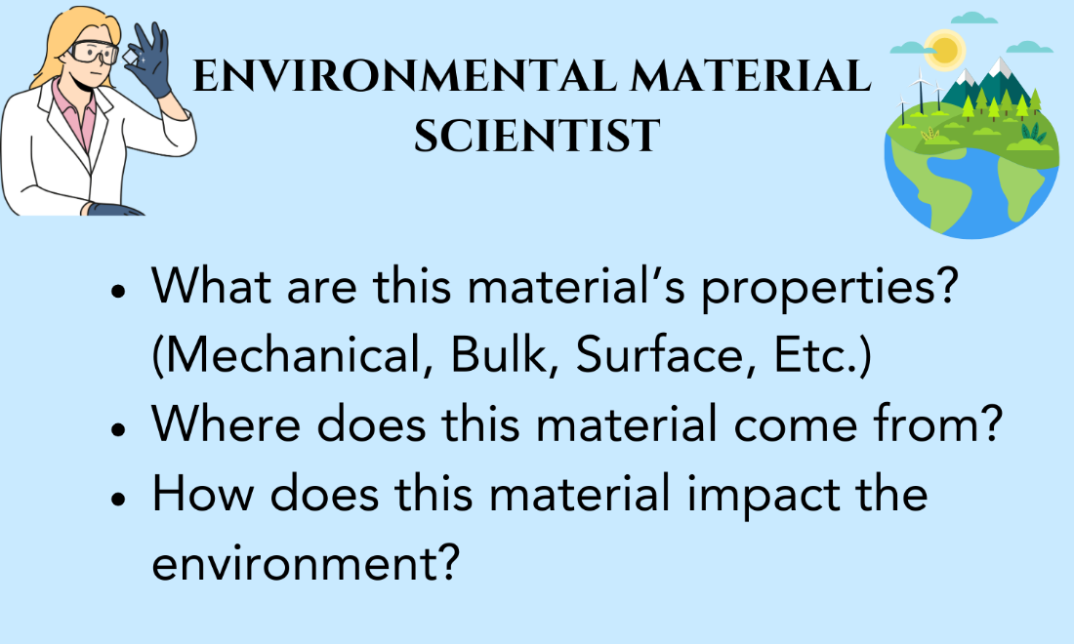

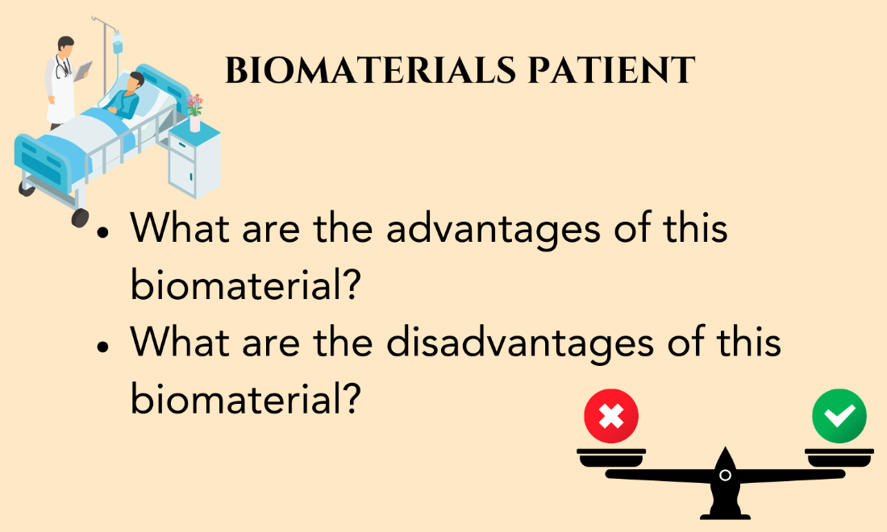

If there needs to be a group of 4 the “Environmental Material Scientist” can be split into the following role cards:

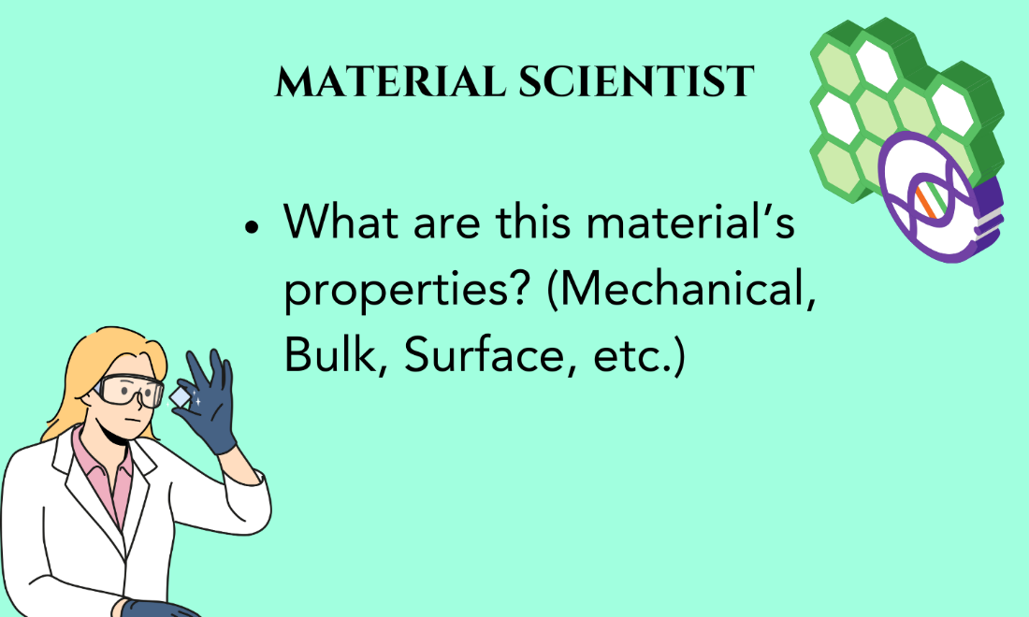
Lesson Title  Lesson # | Lesson 3: Jigsaw Day 2 + Start of Engineering Challenge
Grade Level | Middle School |  | Length of Lesson Time: | 45 minutes
Academic Standards/ CCF | Carrying over from Lesson 2, this lesson will continue to touch on the NGSS practice of Obtaining, Evaluating and Communicating Information.
Lesson Objectives | The learner will be able to (TLWBAT):  - The learner will be able to present their research with their team using scientific language  - The learner will be able to answer Jeopardy style questions about the various materials presented by their peers  The learner will know (TLWK):  - The learner will know the major properties of all classes of biomaterial (ceramics, metals, polymers)  - The learner will know the major advantages of all classes of biomaterial  - The learner will know the major disadvantages of all classes of biomaterial  - The learner will know the major applications and uses of all classes of biomaterial in the medical field  - The learner will know the major sources of all classes of biomaterial and their impact on the environment
Language | Academic Language | Science Language |  | Language Production Strategies
 | Present, discuss, compare, answer questions, demonstrate understanding, learn. | Material properties, mechanical properties, bulk properties, surface properties, environmental impact. |  | Oral presentations given to the class as a group, answering Jeopardy style questions to demonstrate understanding.
Resources | Materials & Technology | Documents & Handouts |  | Volunteers
 | Jigsaw Jeopardy Game Jigsaw Presentation Rubric  Engineering challenge description |  |  | Excellent with a volunteer to fill in any missing concepts from the Jigsaw presentations.  Can still be run very well without a volunteer.
Essential | - Learner engages in scientifically oriented questions

Features of Inquiry | - Learner gives priority to evidence in responding to questions  - Learner communicates and justifies explanations
Instructional Plan | Teacher Talk/Action | Student Talk/Action | Teaching Strategy/ Rationale Essential Feature of Inquiry
 | Class plan:  1-2 minute introduction: jump quickly into the presentations.  25 minutes: Remaining student presentations (~5 minutes presenting, 2 minutes question for each)  20 minutes: Jeopardy questions and announcing winner and announce homework.  - Jigsaw Activity:  - Teacher will ask questions about the presentation to fill in any knowledge gaps.  - Jeopardy:  - Teacher will run a Jeopardy style game to test the understanding of the students on the topics presented by their peers. | - Jigsaw Activity:  - Students will present their Jigsaw presentations that were created in lesson 2.  - Students will present the sections they researched.  - Students will answer questions posed by the teacher.  - Jeopardy:  - Students will choose questions (one group will go at a time) to answer from the Jeopardy game. Students cannot choose the material they presented on.  - Students will discuss with their groups to determine the correct answer. | Learner communicates and justifies explanations:  - Students present their findings from research.  Learner engages in scientifically oriented questions:  - Students answer questions posed by the teacher.  Learner engages in scientifically oriented questions, and learner gives priority to evidence in responding to questions:  - Students participate in Jeopardy game and answer questions as a group based on

 | - Engineering Challenge Homework:  - Teacher will announce the winning group(s), that group will be able to choose the material they want to use for the Engineering Challenge. If there is a tie, both groups can choose materials, there will be either one or two materials to choose from for the challenge.  - Teacher will announce that the winning material is what will be used for the engineering challenge the next day.  - The teacher will announce that the homework for the class is to start thinking of their design based on the material and medical condition voted on prior to the next class period.  - Homework for students is to come to lesson 4 with a drawing or written idea so they are ready to build. | - All groups can answer the question, and will write down their answer on a small white board and hold it up when the teacher decides the time is up.  - Each group will keep track of their scores. | what they have learned from the Jigsaw presentations.
Assessment | Jigsaw student presentations (participation, and understanding of topics) Answering questions from teacher during presentations  Participating in Jeopardy game to answer questions

Jigsaw Presentation Rubric

Student Name:

Scientiﬁc Discourse | Partially Meets (1) | Meets (3) | Exceeds (5)
Language Production | - Student uses non-scientific language during presentation | - Student uses new language during presentation | - Student uses scientific language and knowledge during presentation
Participation | - Student somewhat engages with the group during the sorting activity.  - Student presents their research during presentation. | - Student engages with the group during the sorting activity.  - Student presents their research during presentation. | - Student takes a leading role in the group activity.  - Student presents their research during presentation.
Research Eﬀort and Understanding | - Student used some resources provided to conduct their research and develop their section of the presentation.  - Student demonstrates some understanding of their assigned topic/questions. | - Student used all the resources provided to conduct their research and develop their section of the presentation.  - Student clearly demonstrates understanding of their assigned topic/questions. | - Student clearly put a lot of time and effort in researching and putting together their section of the presentation.  - Student clearly demonstrates understanding of their assigned topic/questions, as well as the topics/questions of other members in the group.

Engineering Challenge Description:

Purpose: The purpose of this engineering challenge day is to allow the students to take what they have learned over the course of the first three lessons and demonstrate their understanding and creativity by creating a product to solve a real medical problem. The material will be decided by the Jeopardy game. The problem, or medical condition, will be decided by anonymous voting by the students. The students will think of what they want to create between lessons 3 and 4 as their homework assignment. They will then come to lesson 4 and create their design using various art supplies (pipe cleaners, etc.) and present their design to the class.

Students will be able to decide if they want to work by themselves or with a partner. This will be decided at the end of lesson 3. For the students that do want to work with partners, the teacher will create groups.
Students can have the option to record their presentation rather than presenting in front of the class.

Lesson Title  Lesson # | Lesson 4: Applications of Biomaterials and Engineering Challenge Day
Grade Level | Middle School |  | Length of Lesson Time: | 45 minutes
Academic Standards/ CCF | MS-ETS1-1: Students who demonstrate understanding can: Define the criteria and constraints of a design problem with sufficient precision to ensure a successful solution, taking into account relevant scientific principles and potential impacts on people and the natural environment that may limit possible solutions.
Lesson Objectives | The learner will be able to (TLWBAT):  - Design and construct a new product by applying what they have learned throughout these lessons.  - Describe their product to their classmates and explain how this product meets the criteria and constraints of the problem, as well as its environmental impact.  The learner will know (TLWK):  - How to define criteria and constraints for a problem  - How to produce a product based on a problem using engineering concepts  - How to present their ideas concisely
Language | Academic Language | Science Language |  | Language Production Strategies
 | Define, describe, present, product, apply. | Criteria, constraints, environmental impact. |  | Written answers to engineering challenge handout. Verbally presenting products to the class. Answering questions from the teacher.
Resources | Materials & Technology | Documents & Handouts |  | Volunteers
 | Engineering Challenge Rubric Engineering Challenge Description Constraints and Criteria | Engineering Challenge Handout  Art supplies (pipe cleaners, string, tape, markers, pens, paper, etc.) |  | Can be run very well without any volunteers
Essential Features of Inquiry | - Learner engages in scientifically oriented questions  - Learner gives priority to evidence in responding to questions  - Learner formulates explanations from evidence

- Learner connects explanations to scientific knowledge
- Learner communicates and justifies explanations
Instructional Plan | Teacher Talk/Action | Student Talk/Action | Teaching Strategy/ Rationale Essential Feature of Inquiry
 | Class Plan:  10 minute introduction  15 minutes on completing the assignment  20 minute rapid fire presentations  - Engineering Challenge Introduction:  - Teacher will introduce constraints and criteria for developing products.  - Teacher will give an example of a constraint and criteria for this specific engineering problem.  - Teacher will ask the class to list more criteria and constraints.  - Engineering Challenge:  - Teacher will split up class into preassigned partners or individuals (determined at the end of lesson 3)  - Teacher will pass out the engineering challenge handout to students along with art supplies. | - Engineering Challenge Introduction:  - Students will list criteria and constraints associated with their engineering challenge.  - Engineering Challenge:  - Students will develop their product.  - Students will answer the questions on the handout to go with the product. | Learner engages in scientifically oriented questions and Learner gives priority to evidence in responding to questions:  - Students list criteria and constraints.  Learner formulates explanations from evidence and Learner connects explanations to scientific knowledge:  - Students use what they’ve learned throughout these lessons to develop a product and answer questions.

 | - Presentations:  - Teacher will split up class into groups of ~5. Each student/partnership will take turns presenting their product.  - Teacher will walk around the class and observe the presentations/participation. | - Presentations:  - Students will split up into groups  - Students will present their products along with the answers to the questions in the handout. This should be very rapid. Only a couple of minutes per student.  - Students will answer questions posed by other students in their small group. | Learner communicates and justifies explanations:  - Students present their products and answer questions posed by other students.
Assessment | Product development (individual or partners) Presentations  Participation in presentations

Constraints and Criteria:

These should be discussed with the students prior to them developing their product. The teacher should introduce what constraints and criteria mean, and then provide several examples. The actual constraints and criteria for the engineering challenge is dependent on the condition that was chosen by students.

Once examples have been provided, the students will be prompted to think of constraints and criteria that they will share. The list of constraints and criteria will be listed on a whiteboard, and will be used as a word bank for students to use when answering their handout questions.

Constraints Definition: Limitations to a design
- Examples:
  - Environmental impact
  - Biocompatibility
  - Manufacturability
  - Cost

Criteria Definition: Things the design needs to do to be successful
- Examples for Hip Replacement:
  - Must resemble the shape of the hip joint
  - Must withstand the forces associated with the hip
  - Must not be toxic, or have toxic components created once the material begins to degrade (Biocompatible)
  - Must function as a hip joint
  - Needs to have a mechanism to stabilize the biomaterial within the hip

Engineering Challenge:

Name:

Instructions: With your partner, or by yourself, you will create a product that solves the medical problem chosen by the class, with the material selected during Jeopardy. You will create this product with the art supplies provided. While you develop your product, determine what constraints/criteria that were discussed at the beginning of class fit your product. Also determine the impact of your product/material on the environment and if there is a way to make your product more environmentally friendly. You must use at least 3 words from the word bank when answering the first question. Constraints and criteria word bank will be listed on the board. You will be presenting your product to small groups, and must also present your answers to the questions below. Participation of both members in a partnership is required.

How does your product fit within the criteria and constraints discussed at the beginning of class?

How will your product impact the environment? Is your product environmentally friendly?

Engineering Challenge Presentation Rubric

Student Name(s):

Scientiﬁc Discourse | Partially Meets (1) | Meets (3) | Exceeds (5)
Language Production | - Student uses non-scientific language during presentation | - Student uses new language during presentation | - Student uses scientific language and knowledge during presentation
Creativity | - Student demonstrates some creativity in the product they have developed. Has similarities to applications previously discussed in class. | - Students develops and presents a novel and creative product | - Students develops and presents a novel and creative product.  - Student is creative in building their product with the supplies provided.
Demonstrates Understanding | - Student put little thought into the design of their product. Showed similar characteristics to previously discussed products.  - Student demonstrates some understanding of the problem that needed solving. | - Student put some thought into the design of their product.  - Student clearly understood the problem that needed to be solved, and developed their product accordingly. | - Student clearly put a lot of thought into the design of their product.  - Student clearly understood the problem that needed to be solved, and developed their product accordingly.
Participation (for partners) | - Only one member of the group participated in product development and presentation. | - Both members of the group participated, however, unequally, in the product development and presentation. | - Both members of the group participated equally in product development and presentation.

Resources for Ceramics:

Advantages and Disadvantages of Ceramics

Singh and colleagues have described ceramics as having similar properties to certain body parts, making them good candidates for implants. In addition, ceramics have excellent biocompatibility, poor degradation, high melting temperature, non-corrosive and better mechanical properties, although more brittle, than metals [1].

Patnaik and colleagues described ceramics as suitable for bone repair and replacement due to the hardness, high wear resistance and excellent biocompatibility. In addition, ceramics produce very little wear debris in comparison with metals and polymers, which is beneficial for applications that involve movement/grinding, such as a hip replacement. However, these ceramics are also expensive, less stable at high temperatures, degrade due to friction and grinding, brittle, and difficult to create [2].

Ballini and colleagues describe ceramic biomaterials as having low tensile strength, meaning it does not respond well to stretching, having high hardness, however, very brittle, meaning the materials can fracture easily under certain stresses [3].

Quote and Table (below) from: Biomaterials: The intersection of biology and material science [4]

1.4.2 Ceramics

Ceramics are inorganic materials composed of nondirectional ionic bonds between electron-donating and electron-accepting elements. Ceramic materials most often employed as biomaterials are listed in Table 1.3. Ceramics may contain crystals or may be noncrystalline (amorphous) glasses. Ceramics are very hard and are more resistant to degradation in many environments compared to metals. However, they are quite brittle because of the nature of ionic bonds. Due to the similarity between the chemistry of ceramics and that of native bone, ceramics are most often used as a part of orthopedic implants or as dental materials. Because of their brittle nature, they are commonly employed in applications requiring small loads.

Table 1.3

Ceramic | Applications
Aluminum | Orthopedic joint replacement components, orthopedic load-bearing implants, implant coatings, dental implants
Bioactive glasses | Orthopedic dental implant coatings, dental implants, facial reconstruction components, bone graft substitute materials
Calcium phosphates | Orthopedic and dental implant coatings, dental implant materials, bone graft substitute materials, bone cements

Quote (below) from: Advantages and Disadvantages of Biomaterials [5]

Ceramics

Alumina, zirconia and pyrolytic carbon are some of the ceramics used as biomaterials in applications such as orthopedic and dental implants. The main advantage is that they are strong and chemically inert. They have high compressive strength, which is necessary for bone implants. Some ceramic materials are also biodegradable. Difficulty in manufacturing forms the main disadvantage. They also can minimize bone ingrowth. Sometimes, implants can loosen over time and become dislodged.

Citations:

- Punj, S., Singh, J., & Singh, K. (2021). Ceramic biomaterials: Properties, state of the art and future prospectives. Ceramics International, 47(20), 28059–28074. https://doi.org/10.1016/j.ceramint.2021.06.238
- Shekhawat, D., Singh, A., Bhardwaj, A., & Patnaik, A. (2021). A short review on polymer, metal and ceramic based implant materials. IOP Conference Series: Materials Science and Engineering, 1017(1), 012038. https://doi.org/10.1088/1757-899x/1017/1/012038
- Vaiani, L., Boccaccio, A., Uva, A. E., Palumbo, G., Piccininni, A., Guglielmi, P., Cantore, S., Santacroce, L., Charitos, I. A., & Ballini, A. (2023). Ceramic materials for biomedical applications: An overview on properties and fabrication processes. Journal of Functional Biomaterials, 14(3), 146. https://doi.org/10.3390/jfb14030146
- Temenoff, J. S., & Mikos, A. G. (2023). Biomaterials: The intersection of biology and materials science. Pearson.
- ShamikaM. (2019, March 2). Advantages & disadvantages of Biomaterials. Sciencing. https://sciencing.com/advantages-disadvantages-biomaterials-8385559.html

Biocompatibility of Ceramics

Ballini and colleagues describe ceramics as generally compatible with human tissue, meaning they reduce the risk of bodily reactions or inflammation to the material. In addition, some ceramics have been shown to promote tissue growth and bone growth. [1]

Singh and colleagues describe ceramics as “having excellent biocompatibility, poor degradability, high melting temperature, non-corrosive…”. Biocompatibility is different for different ceramic materials. For example: Alumina (a type of ceramic used in dental and orthopedic implants) has good biocompatibility within the human body. However, Silicate (another type of ceramic) has been shown to cause cell death. [2]

The book Advances in Ceramics chapter on Biocompatibility discusses the importance of biocompatibility for ceramic biomaterials. Biocompatibility is very important for biomaterials because of the direct contact with human tissue long term. Biocompatibility is also an ongoing process, meaning that just because a material does not cause a response at first, this doesn’t mean it won’t cause a response later on. This book states that the variation in types of ceramics or composition of ceramics makes it difficult to determine the biocompatibility of ceramics in general. This is dependent on the types of ceramics being used. Some ceramic materials can release molecules over time, as the material degrades, that can travel to other tissues within the body and cause problems. [3]

Citations:

- Vaiani, L., Boccaccio, A., Uva, A. E., Palumbo, G., Piccininni, A., Guglielmi, P., Cantore, S., Santacroce, L., Charitos, I. A., & Ballini, A. (2023a). Ceramic materials for biomedical applications: An overview on properties and fabrication processes. Journal of Functional Biomaterials, 14(3), 146. https://doi.org/10.3390/jfb14030146
- Punj, S., Singh, J., & Singh, K. (2021). Ceramic biomaterials: Properties, state of the art and future prospectives. Ceramics International, 47(20), 28059–28074. https://doi.org/10.1016/j.ceramint.2021.06.238
- Sikalidis, C. (Ed.). (2011). Advances in Ceramics - Electric and Magnetic Ceramics, Bioceramics, Ceramics and Environment. InTech. doi: 10.5772/726

Applications of Ceramics in the Medical Field

Quote and Table (below) from: Biomaterials: The intersection of biology and material science [1]

1.4.2 Ceramics

Ceramics are inorganic materials composed of nondirectional ionic bonds between electron-donating and electron-accepting elements. Ceramic materials most often employed as biomaterials are listed in Table 1.3. Ceramics may contain crystals or may be noncrystalline (amorphous) glasses. Ceramics are very hard and are more resistant to degradation in many environments compared to metals. However, they are quite brittle because of the nature of ionic bonds. Due to the similarity between the chemistry of ceramics and that of native bone, ceramics are most often used as a part of orthopedic implants or as dental materials. Because of their brittle nature, they are commonly employed in applications requiring small loads.

Table 1.3
Ceramic | Applications
Aluminum | Orthopedic joint replacement components, orthopedic load-bearing implants, implant coatings, dental implants
Bioactive glasses | Orthopedic dental implant coatings, dental implants, facial reconstruction components, bone graft substitute materials
Calcium phosphates | Orthopedic and dental implant coatings, dental implant materials, bone graft substitute materials, bone cements

Table (below) from: Ceramic materials for biomedical application [2]

Properties and biomedical applications of the main bioceramic materials

Material | Young’s Modulus (GPa) | Compressive Strength (MPa) | Density (g/cm³) | Bioactivity | Applications
Alumina | 380 | 4000 | >3.9 | Inert | Orthopedics, load-bearing applications, dentistry
Zirconia | 150-200 | 2000 | 6.0 | Inert | Orthopedics, load-bearing applications, dentistry
Porous hydroxyapatite | 70-120 | 600 | 3.1 | Bioresorbable | Dentistry, coatings, scaffolds
Tricalcium phosphate | 120-160 | 540 | 3.1 | Bioresorbable | Dentistry, scaffolds
Bioactive glasses | 75 | 1000 | 2.5 | Bioactive | Dentistry, spinal surgery

Citations:
- Temenoff, J. S., & Mikos, A. G. (2023). Biomaterials: The intersection of biology and materials science. Pearson.
- Vaiani, L., Boccaccio, A., Uva, A. E., Palumbo, G., Piccininni, A., Guglielmi, P., Cantore, S., Santacroce, L., Charitos, I. A., & Ballini, A. (2023a). Ceramic materials for biomedical applications: An overview on properties and fabrication processes. Journal of Functional Biomaterials, 14(3), 146. https://doi.org/10.3390/jfb14030146

Environmental Impact of Ceramics

Singh and colleagues discuss the environmentally friendly options for ceramic biomaterials. They state that “Agro-Food waste” derived ceramics, meaning those that are derived from agricultural waste, or food waste have benefits over synthetic ceramics. These include improved biocompatibility, since these are naturally derived ceramics, limited tissue rejection of the material/implant, and good biodegradability. Agro-Food waste ceramics are non-toxic, cheap to produce, and environmentally friendly since they use natural waste products. [1]

Hasmaliza and colleagues discuss the environmentally friendly option for ceramic biomaterials composed from rice husk ash and rice straw ash. These agricultural waste products can be used to create the ceramic material called “Wollastonite”. This material can be used for bone and teeth replacement materials. The use of these agricultural waste products reduces the environmental impact of ceramic fabrication, and reduces the pollution caused from agricultural waste. [2]

Henriques and colleagues compared the environmental impact of metal versus ceramic biomaterials. Although ceramics were found to have a lower impact on the environment, this impact was not zero. These ceramics have a carbon footprint that affects the environment. [3]

Citations:

- Punj, S., Singh, J., & Singh, K. (2021a). Ceramic biomaterials: Properties, state of the art and future prospectives. Ceramics International, 47(20), 28059–28074. https://doi.org/10.1016/j.ceramint.2021.06.238
- Ismail, H., & Mohamad, H. (2021). Bioactivity and biocompatibility properties of sustainable wollastonite bioceramics from rice husk ash/rice straw ash: A Review. Materials, 14(18), 5193. https://doi.org/10.3390/ma14185193
- De Bortoli, L. S., Schabbach, L. M., Fredel, M. C., Hotza, D., & Henriques, B. (2019). Ecological footprint of Biomaterials for implant dentistry: Is the metal-free practice an eco-friendly shift? Journal of Cleaner Production, 213, 723–732. https://doi.org/10.1016/j.jclepro.2018.12.189

Additional Resources for Material Properties of Ceramics

Ballini and colleagues describe the material properties of ceramics as:

Chemical properties: Ceramics can be classified as inert, meaning non-active, low or medium active, and bioresorbable, meaning they degrade within the body. Inert ceramics are often used for permanent implants and do not interact with tissues in the body, they are purely there to provide structure. Low and medium active ceramics can help bind proteins, or release molecules and with these actions they interact with surrounding tissue helping to heal the body. Resorbable ceramics degrade over time, because of this, they have a large interaction with the surrounding tissue. As the ceramic degrades, the tissue grows and takes over the space in the body the ceramic was taking up. This type of ceramic promotes healing and tissue growth.

Mechanical Properties: Ceramics do not have a lot of tensile strength, meaning they do not respond well to stretching. They are very hard materials, however, they are very brittle and can break or fracture easily under certain stresses.

In addition, they describe the primary characteristics and properties of ceramic biomaterials as being stiff and having high strength, very hard material, is insulating, and resists high temperatures within the body.

Citation:

- Vaiani, L., Boccaccio, A., Uva, A. E., Palumbo, G., Piccininni, A., Guglielmi, P., Cantore, S., Santacroce, L., Charitos, I. A., & Ballini, A. (2023a). Ceramic materials for biomedical applications: An overview on properties and fabrication processes. Journal of Functional Biomaterials, 14(3), 146. https://doi.org/10.3390/jfb14030146

Resources for Metals:

Advantages of Metals

Patnaik and colleagues describe metals as having superior mechanical properties, being lightweight, biocompatible, cheap to manufacture, wear resistant, corrosion resistant, depending on the type of metal that is used, for example, stainless steel is created to be corrosion resistant while not all metals have this property. [1]

Quote and Table (below) from: Biomaterials: The intersection of biology and material science [2]

1.4.1 Metals

Metals are inorganic materials possessing nondirectional metallic bonds with highly mobile electrons (see Section 1.7 for more about bond types). A list of metals and alloys (combinations of multiple elemental metals) commonly used in biomedical applications can be found in Table 1.2. In addition to their ability to conduct electricity, metals are strong and relatively easily formed into complex shapes. This makes metals a suitable material for orthopedic (hip and knee) replacements (Fig. 1.4), for dental fillings and implants for craniofacial restoration, and for cardiovascular applications such as stents and pacemaker leads.

Table 1.2

Metals Commonly Used in Biomedical Applications

Metals | Applications
Cobalt-chromium alloys | Artificial heart valves, dental prostheses, orthopedic fixation plates, artificial joint components, vascular stents
Gold and platinum | Dental fillings, electrodes for cochlear implants
Silver-tin-copper alloys | Dental amalgams
Stainless steel | Dental prostheses, orthopedic, fixation plates, vascular stents
Titanium alloys | Artificial heart valves, dental implants, artificial joint components, orthopedic screws, pacemaker cases, vascular stents

Quote (below) from: Advantages and Disadvantages of Biomaterials [3]

Metal

Stainless steel, gold, cobalt-chromium alloy and nickel-titanium alloy are the most commonly metals used as biomaterials. Applications include bone and joint replacements, dental implants and pacemaker cases. The main advantages of metals are that they are strong and are resistant to fatigue degradation. They have shape memory and can be sterilized easily before use. The main disadvantage is that metal can corrode due to chemical reaction with the body enzymes and acids. It also can cause metal ion toxicity in the body.

Citations:

- Shekhawat, D., Singh, A., Bhardwaj, A., & Patnaik, A. (2021). A short review on polymer, metal and ceramic based implant materials. IOP Conference Series: Materials Science and Engineering, 1017(1), 012038. https://doi.org/10.1088/1757-899x/1017/1/012038
- Temenoff, J. S., & Mikos, A. G. (2023). Biomaterials: The intersection of biology and materials science. Pearson.
- ShamikaM. (2019, March 2). Advantages & disadvantages of Biomaterials. Sciencing. https://sciencing.com/advantages-disadvantages-biomaterials-8385559.html

Disadvantages of Metals

Patnaik and colleagues describe metal biomaterials as having the potential to cause allergic reactions, being expensive, depending on the type of metal, low shear stress, releasing ions that can affect the tissue surrounding the implant. Metals can also fracture after implantation, certain metals can also have lower strength and be corrosive. For bone healing/implants, metal biomaterials also have the ability to resorb, or degrade, surrounding healthy bone. [1]

Quote (below) from: Advantages and Disadvantages of Biomaterials [3]

Metal

Stainless steel, gold, cobalt-chromium alloy and nickel-titanium alloy are the most commonly metals used as biomaterials. Applications include bone and joint replacements, dental implants and pacemaker cases. The main advantages of metals are that they are strong and are resistant to fatigue degradation. They have shape memory and can be sterilized easily before use. The main disadvantage is that metal can corrode due to chemical reaction with the body’s enzymes and acids. It also can cause metal ion toxicity in the body.

Citations:

- Shekhawat, D., Singh, A., Bhardwaj, A., & Patnaik, A. (2021). A short review on polymer, metal and ceramic based implant materials. IOP Conference Series: Materials Science and Engineering, 1017(1), 012038. https://doi.org/10.1088/1757-899x/1017/1/012038
- Temenoff, J. S., & Mikos, A. G. (2023). Biomaterials: The intersection of biology and materials science. Pearson.
- ShamikaM. (2019, March 2). Advantages & disadvantages of Biomaterials. Sciencing. https://sciencing.com/advantages-disadvantages-biomaterials-8385559.html

Biocompatibility of Metals

Eliaz states that things such as the size and shape of an implant, in addition to its composition, surface roughness, and surface hydrophobicity can all affect biocompatibility. In addition to these factors, and most specific to metal biomaterials, how corrosive a biomaterial is has a large impact on biocompatibility. Corrosion is defined as the degradation or weakening of a material, this can sometimes be visualized through rusting of metals. Corrosion can impact the functionality of an implant, and the strength of an implant. Corrosion can also lead to the release of ions from the metal biomaterial which can be toxic to surrounding tissue. [1]

Bazaka and colleagues state that surface modifications of metal biomaterials are a common way to improve biocompatibility. A rough surface as well as a porous surface help to improve cellular interaction and tissue growth within the biomaterial, thereby increasing the materials biocompatibility. Antibacterial coatings are also used to prevent the attachment of bacteria to the implant, which could lead to a rejection of the implant. In addition to surface modifications, bulk modifications can also improve biocompatibility. Alloying (or combining) metals, or creating pores throughout the material can improve biocompatibility. However, there are downsides to increasing porosity. This can increase degradation rate, even of metals that aren’t intended to be degraded within the body. This could lead to a large increase in ion release, and ion toxicity. [2]

Citations:

- Eliaz, N. (2019). Corrosion of metallic biomaterials: A Review. Materials, 12(3), 407. https://doi.org/10.3390/ma12030407
- Prasad, K., Bazaka, O., Chua, M., Rochford, M., Fedrick, L., Spoor, J., Symes, R., Tieppo, M., Collins, C., Cao, A., Markwell, D., Ostrikov, K. (Ken), & Bazaka, K. (2017). Metallic biomaterials: Current challenges and opportunities. Materials, 10(8), 884. https://doi.org/10.3390/ma10080884

Applications of Metals in the Medical Field

Quote and Table (below) from: Biomaterials: The intersection of biology and material science [1]

1.4.1 Metals

Metals are inorganic materials possessing nondirectional metallic bonds with highly mobile electrons (see Section 1.7 for more about bond types). A list of metals and alloys (combinations of multiple elemental metals) commonly used in biomedical applications in found in Table 1.2. In addition to their ability to conduct electricity, metals are strong and relatively easily formed into complex shapes. This makes metals a suitable material for orthopedic (hip and knee) replacements (Fig. 1.4), for dental fillings and implants for craniofacial restoration, and for cardiovascular applications such as stents and pacemaker leads.

Table 1.2

Metals Commonly Used in Biomedical Applications

Metals | Applications
Cobalt-chromium alloys | Artificial heart valves, dental prostheses, orthopedic fixation plates, artificial joint components, vascular stents
Gold and platinum | Dental fillings, electrodes for cochlear implants
Silver-tin-copper alloys | Dental amalgams
Stainless steel | Dental prostheses, orthopedic, fixation plates, vascular stents
Titanium alloys | Artificial heart valves, dental implants, artificial joint components, orthopedic screws, pacemaker cases, vascular stents

Quote (below) from: Advantages and Disadvantages of Biomaterials [2]

Metal

Stainless steel, gold, cobalt-chromium alloy and nickel-titanium alloy are the most commonly metals used as biomaterials. Applications include bone and joint replacements, dental implants and pacemaker cases. The main advantages of metals are that they are strong and are resistant to fatigue degradation. They have shape memory and can be sterilized easily before use. The main disadvantage is that metal can corrode due to chemical reaction with the body enzymes and acids. It also can cause metal ion toxicity in the body.

Citations:
- Temenoff, J. S., & Mikos, A. G. (2023). Biomaterials: The intersection of biology and materials science. Pearson.
- ShamikaM. (2019, March 2). Advantages & disadvantages of Biomaterials. Sciencing. https://sciencing.com/advantages-disadvantages-biomaterials-8385559.html

Environmental Impact of Metals

Raito and colleagues discuss the impacts of metal mining on the environment. All aspects of mining activities can have negative impacts on the environment such as deforestation in the region of mining, erosion of the earth, contamination of soil, contamination of water, and increase in noise, dust and carbon emissions. The abandonment of the mines can also result in these environmental impacts. [1]

Raabe discusses sustainable metals and alloys. Production of metals accounts for approximately 40% of greenhouse gas emissions by industries, as well as 10% of global energy use, and 3.2 billion tons of mined minerals, and produces billions of tons of by-products, or unwanted products that are created throughout metal production. Ways of creating sustainable metals are being researched. One method is recycling scraps of metal, melting them down and reusing them for future production. [2]

Citations:

- Haddaway, N. R., Cooke, S. J., Lesser, P., Macura, B., Nilsson, A. E., Taylor, J. J., & Raito, K. (2019). Evidence of the impacts of metal mining and the effectiveness of mining mitigation measures on social–ecological systems in Arctic and boreal regions: A systematic map protocol. Environmental Evidence, 8(1).
https://doi.org/10.1186/s13750-019-0152-8
- Raabe, D. (2023). The materials science behind Sustainable Metals and alloys.
Chemical Reviews, 123(5), 2436–2608. https://doi.org/10.1021/acs.chemrev.2c00799

Material Properties of Metals

Mechanical Properties: The mechanical properties of metal biomaterials include a high strength, ductile, meaning it is more capable of stretching than ceramics, tough, fatigue-resistant, meaning they don’t degrade with forces over time, and less brittle than ceramics. [1]

Chemical properties: Metals can be corrosive or corrosive resistant. This corrosiveness can lead to loss of ions through degradation of the material once implanted. These ions can be toxic to surrounding tissue. This corrosion can also weaken and change the mechanical properties of the metal. [2]

Citation:

- Niinomi, M., & Nakano, T. (2019). Mechanical properties of metallic biomaterials. In
Metals for biomedical devices. essay, Woodhead.
- Eliaz, N. (2019a). Corrosion of metallic biomaterials: A Review. Materials, 12(3), 407. https://doi.org/10.3390/ma12030407

Resources for Polymers:

Advantages of Polymers

Patnaik and colleagues describe polymers as being tailorable, meaning they can be modified to fit a certain application. For example, if one polymer is very stiff, and another polymer is very flexible, but for an application we need something in between these two polymers, they can be combined to create a composite polymer. Since polymers can be modified significantly in terms of their material properties, they can have great mechanical properties, and be wear resistant, they can be biodegradable, they tend to be biocompatible, low cost, easily moldable, and
non-toxic [1].

Quote (below) from: Advantages and Disadvantages of Biomaterials [2]

Polymer

Polymers include collagen, nylon and silicones. They are used in tissue repair, heart valves and breast implants. Polymers are widely used as they can be manufactured to adapt to their use. They are easy to manufacture and modify. They are also biodegradable, which is both an advantage and disadvantage. Due to the intensive interaction with the body, they can leach, leading to wear and tear. They also can absorb important nutrients and water from the blood.

Citations:

- Shekhawat, D., Singh, A., Bhardwaj, A., & Patnaik, A. (2021). A short review on polymer, metal and ceramic based implant materials. IOP Conference Series: Materials Science and Engineering, 1017(1), 012038. https://doi.org/10.1088/1757-899x/1017/1/012038
- ShamikaM. (2019, March 2). Advantages & disadvantages of Biomaterials. Sciencing. https://sciencing.com/advantages-disadvantages-biomaterials-8385559.html

Disadvantages of Polymers

Patnaik and colleagues describe polymers as capable of releasing debris, causing adverse tissue reactions. Depending on the polymer they can cause bone degradation, fracture, and can have low wear resistance. Since polymers are modifiable the disadvantages can often be overcome by combining with another polymer to create a composite. [1]

Quote (below) from: Advantages and Disadvantages of Biomaterials [2]

Polymer

Polymers include collagen, nylon and silicones. They are used in tissue repair, heart valves and breast implants. Polymers are widely used as they can be manufactured to adapt to their use. They are easy to manufacture and modify. They are also biodegradable, which is both an advantage and disadvantage. Due to the intensive interaction with the body, they can leach, leading to wear and tear. They also can absorb important nutrients and water from the blood.

Definition of Leach: dissolving of the material

Citations:
- Shekhawat, D., Singh, A., Bhardwaj, A., & Patnaik, A. (2021). A short review on polymer,
metal and ceramic based implant materials. IOP Conference Series: Materials Science and Engineering, 1017(1), 012038. https://doi.org/10.1088/1757-899x/1017/1/012038
- ShamikaM. (2019, March 2). Advantages & disadvantages of Biomaterials. Sciencing. https://sciencing.com/advantages-disadvantages-biomaterials-8385559.html

Biocompatibility of Polymers

Fukushima and colleagues discuss how the biocompatibility of polymers can be modified through various surface properties, such as hydrophobicity and the charge of the surface. These surface modifications can alter cell interaction with the polymers and can therefore limit bodily responses. [1]

Langer and colleagues discuss the various surface modifications that can be added to polymers to improve biocompatibility. This includes altering surface hydrophobicity. [2]

Brabazon and colleagues discuss surface modifications to improve polymer biocompatibility. Characteristics that affect biocompatibility include surface structure, chemical structure, hydrophobicity, cytotoxicity, or the ability of a material to kill cells which decreases biocompatibility. Surface modifications can be made to improve biocompatibility, this includes sterilization of the polymer prior to implantation, surface roughness, surface hydrophobicity. [3]

Citations:

- Jurak, M., Wiącek, A. E., Ładniak, A., Przykaza, K., & Szafran, K. (2021). What affects the biocompatibility of polymers? Advances in Colloid and Interface Science, 294, 102451. https://doi.org/10.1016/j.cis.2021.102451
- Kohane, D. S., & Langer, R. (2008). Polymeric biomaterials in tissue engineering. Pediatric Research, 63(5), 487–491. https://doi.org/10.1203/01.pdr.0000305937.26105.e7
- Ul Ahad, I., Bartnik, A., Fiedorowicz, H., Kostecki, J., Korczyc, B., Ciach, T., & Brabazon,
D. (2013). Surface modification of polymers for biocompatibility via exposure to extreme ultraviolet radiation. Journal of Biomedical Materials Research Part A, 102(9),
3298–3310. https://doi.org/10.1002/jbm.a.34958

Applications of Polymers in the Medical Field

Table (below) from: Biomaterials: The intersection of biology and material science [1]

Table 1.4

Synthetic and Naturally Derived Polymers Commonly Used in Biomedical Applications

Polymer | Applications
Synthetic
Poly(2-hydroxyethyl methacrylate) | Contact lenses
Poly(dimethyl siloxane) | Breast implants, contact lenses, knuckle replacements
Poly(ethylene) | Orthopedic joint implants
Poly(ethylene glycol) | Pharmaceutical fillers, wound dressings
Poly(ethylene terephthalate) | Vascular grafts, sutures
Poly(ε-caprolactone) | Drug delivery devices, sutures
Poly(lactic-co-glycolic acid) | Resorbable meshes and sutures
Poly(methyl methacrylate) | Bone cements, diagnostic contact lenses
Poly(tetrafluoroethylene) | Vascular grafts, sutures
Poly(isoprene) | Gloves
Poly(propylene) | Sutures
Naturally derived
Alginate | Wound dressings
Chitosan | Wound dressings
Collagen | Orthopedic repair matrices, nerve repair matrices, tissue-engineering matrices
Elastin | Skin repair matrices
Fibrin | Hemostatic products, tissue sealants
Glycosaminoglycan | Orthopedic repair matrices
Hyaluronic acid | Orthopedic repair matrices

Table (below) from: Biomaterials Classifications [2]

Polymers | Biodegradable  Biocompatible  Easily moldable and readily available | Leachable in body fluids  Hard to sterilize | Orthopedic and dental implants  Prostheses  Tissue engineering scaffolds
E.g. PMMA-, Polycaprolactone (PCL), PLA, polycarbonates, polyurethanes | Suitable mechanical strength | Hard to sterilize | Drug delivery systems

Citations:
- Temenoff, J. S., & Mikos, A. G. (2023). Biomaterials: The intersection of biology and materials science. Pearson.
- Biomaterials classification with their advantages, disadvantages, and applications. (n.d.). https://www.ncbi.nlm.nih.gov/books/NBK578292/

Environmental Impact of Polymers

Edirisinghe and colleagues discuss the environmental impact of producing polymers. The process of creating a polymer through chemical reactions does not directly impact the environment in a negative way. However, if the reactions are hazardous and get out of control this can cause fires or even explosions. Synthetic polymers that are obtained from petroleum sources are an environmental concern. Obtaining petroleum causes disruptions of wildlands and habitats along with creating pollution through leaking of toxic substances from oil wells and processing facilities. Some things that are added to the polymer in its production process have the potential to contaminate soil, water, air and food. [1]

Some polymers can be sensitive to moisture and heat. If the polymers need to be sterilized, which is often the case prior to implanting a material into the body, then they undergo sterilization by ethylene oxide. The use of ethylene oxide is converted into a very harmful substance during this process. This is known to cause cancer and can impact plants, animals and humans, and therefore has a large impact on the environment. Since this technique is used for moisture and heat sensitive materials it is mostly used for polymers, and not as often used for metals or ceramics. [2]

Citations:

- Amarakoon, M., Alenezi, H., Homer‐Vanniasinkam, S., & Edirisinghe, M. (2022). Environmental impact of polymer fiber manufacture. Macromolecular Materials and Engineering, 307(11). https://doi.org/10.1002/mame.202200356
- Ethylene oxide. DCCEEW. (n.d.). https://www.dcceew.gov.au/environment/protection/npi/substances/fact-sheets/ethylene- oxide#:~:text=Ethylene%20oxide%20is%20converted%20to,low%20growth%20rates%2 0in%20plants.

Additional Polymer Resources

Polymers are flexible, however, their mechanical properties can be modified by creating composite polymers (multiple polymers combined into one material). However, metals and ceramics will usually be a stronger material even compared to polymer composites. Polymers are less brittle than metals and ceramics. Polymers can be biodegradable, and are biocompatible.[1]

Since polymers are modifiable they don’t have a consistent set of characteristics or material properties. However, polymers do come in different forms, below three types of polymers are described. Include this information in the material properties section of your powerpoint.

Quote (below) from: Biomaterials: The intersection of biology and material science [2]

Regardless of the origin of the polymer, there are several polymer sub-classes that are useful to the biomaterialist in that each may be particularly suited to certain tissue types. For example, elastomers can sustain substantial deformation at low stresses and return rapidly to their initial dimensions upon release of the stress, suggesting that they may be suitable for cardiovascular called hydrogels exhibit the ability to swell in water and to retain a significant fraction of water within their structures without completely dissolving. Due to their high water content, hydrogels have been explored for a variety of soft tissue applications.

It is also possible to form composite materials to improve bulk or surface properties of biomaterials. Composites are materials consisting of two or more chemically distinct components, one of which is often a polymer. Composites are often created to optimize mechanical properties. For example, a fiber-reinforcing material (usually carbon) can be dispersed throughout a polymer. Although a detailed discussion of composite materials is beyond the scope of this text, it is interesting to note that many consider the structure of human tissues to resemble a fiber-reinforced composite.

Citations:

- Pradhan, S., Rajamani, S., Agrawal, G., Dash, M., & Samal, S. K. (2017). NMR, FT-IR and Raman characterization of Biomaterials. Characterization of Polymeric Biomaterials, 147–173. https://doi.org/10.1016/b978-0-08-100737-2.00007-8
- Temenoff, J. S., & Mikos, A. G. (2023). Biomaterials: The intersection of biology and materials science. Pearson.

