Biomedical engineering
lesson plan

Adaptable for Grades 6-8
Can be adapted for two 90-minute plans or four 45-minute plans

Surgical Robots

Developed by Kiara Quinn
National Institute of Biomedical Imaging and Bioengineering
BEAMS Challenge

BEAMS Lesson Plan Disclaimer

This lesson plan and materials were created by participants who submitted materials in response to the NIBIB Bioengineering Adapted for Middle School (BEAMS) Challenge. Every attempt has been made to verify the accuracy of the content. The external links to nonfederal websites included in these materials provide additional information and resources. NIBIB cannot attest to the accuracy or accessibility of a nonfederal site. The statements, opinions or conclusions contained in these materials do not necessarily represent the statements, opinions or conclusions of the NIH, its component institutes and centers, or the United States government. These materials are in the public domain and may be used and adapted freely.

Some images may only be used in these materials and not for other purposes. Please see our copyright policy for further information.

TEACHER GUIDE
Biomedical engineering adapted for middle school
GRADE LEVEL: 6-8
TOPIC: SURGICAL ROBOTICS

PRESENTER NOTES PART 1:
(Slide 1) Start by telling students that today’s lesson will focus on biomedical engineering and surgical robots. They will learn what engineers do! Maybe some of them might want to be engineers when they grow up. To engage students, begin by asking open-ended discussion questions. Examples of questions are provided below, but feel free to tailor the questions to your students:
Can you think of an example of where a tool, technology, or even a robot helped solve a problem?
Possible Answers: Students may have heard of robots that help their parents vacuum (Roombas) or robots that can help look things up (Alexa/Echo), but even if they haven’t teachers can give examples that are as simple as a calculator to solve math problems.

Does anyone know someone who is an engineer? Do you know what engineers do?
Possible Answers: Answers will vary, but this will be a good lead in to slide 2: Who is an engineer?

(Slide 2) Explain that solving problems is what engineers do every day! They find a problem and think of solutions to address it, such as designing or building a tool. These tools can be digital or physical products.
DEI statement: Be careful not to use he/him pronouns when describing an engineer. Although engineering is traditionally a male-dominated field, this is improving every day. This improvement starts by eliminating unconscious bias and ensuring students of all gender identities can ‘see’ themselves as an engineer.

(Slide 3) Explain to students that there are different types of engineers. Biomedical engineers are a specific type of engineer. They look for problems that are related to our health and medicine. For example, they might think about problems doctors face when treating patients. Doctors have a very difficult and important job, so it can be really useful for them to have tools and devices that can help assist them.

(Slide 4) How do engineers come up with a solution to a problem? They follow a simple process to make it easier. Encourage students by telling them they can also use this process and practice being an engineer. The process is called the engineering design process. It can be broken down into five steps. Tell students that they will learn and get to practice these steps today!

(Slide 5) Over the next couple of days they will learn about an example of using the engineering design process to create a tool for surgeons. Make sure students know who a surgeon is. If they are not familiar, explain that a surgeon is a special type of doctor who helps people by performing surgery. Surgery is when they use special tools and techniques to fix or remove something inside a person's body to make

them feel better. They have to be very skilled and careful because their work can have a big impact on a person's health and well-being. Surgeons help make people healthier and are like superheroes in the hospital, using their expertise to save the day!

Because surgeons have such an important job, biomedical engineers have helped make their job easier by building surgical robots. A surgical robot is like a helper for surgeons. It's a special machine that doctors use during surgery to make the surgery even more precise and safe. Just like a video game, surgeons can control the robot using a computer. The robot has special arms with tiny tools on the end that can go into a person's body through small cuts. It's like having an extra pair of very careful hands during surgery. This makes surgeries safer and can help people get better faster.
You can point out how in the picture, the surgeon is sitting at the chair on the left and is controlling the robot in the center. The surgeon can see a real-time video that is magnified, which means it's like a really close-up view of what's happening inside the person's body. You can also see that the surgeon has a lot of assistants who are double checking the patient is safe.
(Slide 6) Surgical robots might seem really complicated, so how did an engineer come up with all of this? Using the engineering design process! They started by identifying a problem. They can do this by researching online or in books. Or they can ask experts, like the doctors and surgeons themselves. This is a good time to remind students that the engineering design process requires teamwork!
Depending on their level, you can ask students to think about what problems surgeons might face. Encourage them to use their imagination and think about the challenges that a surgeon might face during surgery. This might even give them the opportunity to ‘see’ themselves as a doctor. Some of the students may want to be a surgeon when they grow up. This small participation not only engages critical thinking but may help foster a student’s dream. You can write their ideas down on the board (if they see these ideas actively written compared to already made on a slide, they will feel more engaged and empowered). If students are stuck, here is a list of a few:
- Some parts of the body are too small or hard to get to (Have any of them ever played the game Operation where they have to try to pick up small tiny pieces?)
- Sometimes surgeries can take a very long time. It can be tiring for the surgeon to stand and keep their hand very steady for a long time. (Just like when a student is playing their favorite sport, they might get tired if they play for a long time, right? Well, surgeons can get tired too, but they can't afford to make mistakes. They need to keep their hands very steady to do their job perfectly.)
- Patients get better faster when surgeons make smaller cuts (Think of a paper cut compared to a larger cut).
(Slide 7) Once engineers have a list of problems (like the ones on the board), they can start to plan or brainstorm solutions. It is important to think before immediately jumping into building something. When they are brainstorming, they come up with a list of criteria and constraints. Criteria are the requirements that the tool needs to meet. Students can think of it like a checklist. Constraints are the limits or boundaries. This can be a hard concept to grasp; an example can help illustrate the difference. Using a sports game as an example, the criteria for playing soccer might be that they need two goals and enough players. Constraints might be that recess time is only 20 minutes long (time constraint) or that they only have cones instead of a net to make a ‘goal’ (materials constraint).
Three criteria of the surgical robot are that it needs to be easy to use, small, and reliable.

Two constraints are that it needs to be cheap (need to replace parts often), cannot heat up (if it gets too hot it can hurt the patient). This is a good time for teachers to discuss how energy is spontaneously transferred out of hotter regions or objects (e.g., the surgical robot) and into colder ones (e.g., body tissues) to work towards core ideas in MS-PS3-3.
(Slide 8) Now there is a list of problems, criteria, and constraints. The next step is to come up with a design and build a prototype. Students will get a chance to build their own today! But first, show them how a real surgical robot meets the criteria and constraints that were discussed.
The Da Vinci Robot is one of the most famous surgical robots (the picture shown in the slide). It has tiny hands that are easy to use, small, and reliable. When the surgeon moves their wrist or fingers, the robots joints move too. It is so small, it can fold a penny sized origami crane (video in slides). It also meets the constraints. Even though the entire device is expensive, the arms/hands shown in the picture here are cheap and can be replaced by disconnecting them from the larger equipment. They are cheap because instead of electrical motors, it uses a cable and pulley system. Emphasize that this cable-pulley system helps prevent the robot from getting hot during surgeries. It eliminates any concern of thermal energy transfer into the body. Explain that in any machine, including robots, when electrical motors work, they produce heat, which can be a problem during surgeries. Discuss how in the Da Vinci Surgical Robot, they have designed it in a way that minimizes the heat generated during surgery, ensuring the patient's safety and comfort. Any motors are placed far from the patients’ body.
(Slide 9) Students now get to make their own prototype, but with added constraints (they are limited to the materials they have in the classroom). A prototype is the model or test version of a design.
Modifications for different learning preferences: A pre-designed template and instructions are provided for learners who prefer a structured approach. Encourage students to be creative and think outside the box. Let them know that it's perfectly fine to come up with their own variations or innovative ideas, even if they use a template as a foundation.

PRESENTER NOTES PART 2:
This lesson will focus on the last two stages of the engineering design process. Start the class by discussing how the building of their prototype went. Ask students what they found most challenging and what they enjoyed about the building process.

Students will likely have a variety of answers, but it's important to reassure them that what they achieved is indeed challenging, yet the challenge can be a lot of fun! The final solution they come up with can be very rewarding because it has the potential to make a significant difference in the lives of patients.

(Slide 10) Once a first prototype is made, engineers need to spend a lot of time testing and improving their design. The problems are challenging but this is why it is important for engineers to make multiple designs! Rarely do they achieve a 'perfect' design on the first attempt. Today, we will discuss methods for testing their design, and their team can brainstorm ways to enhance it. Each group of students will need to come up with at least one improvement idea and test its effectiveness.

Explain to students that, for testing, engineers try to find quantitative outcome measures. "Quantitative" means using numbers to describe or measure things. It's a way of talking about something in a precise and specific way, as opposed to using vague words like ‘good’ or ‘fast’.

Some quantitative examples of tests that students can conduct include timing how long it takes to move 10 blocks from one location to another using their device. Another quantitative test could be counting their success rate, which is the number of times they successfully move the block from one place to another without dropping it, divided by 10 trials. Encourage students to devise their own quantitative tests.

Paper block templates are provided for students to pick up with their surgical robots. Give students about 10 minutes to complete this initial test.

After the initial testing, give students 20-30 minutes to work on improving their designs.

Flexibility in scheduling: If you're splitting the lesson into two 45-minute sections, this is a good point to pause and resume the next day.

(Slide 11) The final step of the engineering design process is to present solutions. This step is crucial because engineers can showcase their useful tools and receive feedback for further rounds of improvement.

Give each group the chance to present their solutions and share whether their improvements were successful or not. This should take a maximum of 20 minutes.

Then, students can fill out the reflection (attached separately) individually or as part of their group.

If time permits, the class can also have a friendly competition to see which group designed the most effective surgical robot.

LESSON PLAN
Biomedical engineering adapted for middle school
GRADE LEVEL: 6-8
TOPIC: SURGICAL ROBOTS

LESSON SUMMARY:
Students will delve into the exciting world of biomedical engineering and explore one of its groundbreaking applications, surgical robots. Biomedical engineers play a vital role in designing and creating innovative devices that enhance medical treatments. A prime example of this is the development of surgical robots, which are engineered to assist surgeons in improving precision, minimizing errors, and reducing surgical invasiveness. This lesson not only introduces the concept of biomedical engineering and surgical robots but also engages students in a hands-on activity where they will work in teams to design and create their own surgical robot prototypes. Through this process, students will learn and practice the engineering design process.

The lesson can be divided into either two 90-minute sessions (1 and 2) or four 45-minute sessions (1A, 1B, 2A, and 2B).
Part 1A: Introduction to biomedical engineering and surgical robots Part 1B: Building their initial surgical robot prototype (Hands-on Activity) Part 2A: Testing and optimization of the prototype (Hands-on Activity)
Part 2B: Final Demonstration, optional competition, and student self-reflection assessment

OBJECTIVES:
Students will be able to:
- Define biomedical engineering.
- Describe and apply the five steps of the engineering design process.
- Discuss the impact of surgical robots.
- Explain the difference between criteria and constraints.
- Employ engineering design principles to build and test a surgical robot prototype.
- Compare at least two different design solutions.
- Practice effectively presenting their designs to peers.

MATERIALS (COST $0-$5):
- Cardboard/Paper (Downloadable template available)
- Tape or glue
- Marker or pencil
- Scissors
- Rubber Bands
- String
Optional: Other classroom or household materials can be used based on students’ creativity.

NEW VOCABULARY:
Engineer: Person who designs or builds solutions to solve a problem
Biomedical Engineering: Type of engineer who solves problems related to human health/medicine. Engineering design process: Multi-step process that engineers use to create solutions to a problem. Prototype: First model or test version of a design.
Surgical Robots: Small, reliable, easy to use robots designed to assist surgeons in performing surgery.
Criteria: Requirements that a tool needs to meet (the checklist)
Constraint: Limits or boundaries that need to be met when designing a tool

ACTIVITY:
The hands-on activity will guide students step-by- step through the steps of the engineering design process. Students will work in teams (2-4 students but can be adjusted based on overall class size and resources) to design, build, test, improve, and present a surgical robot prototype. An optional competition at the end can help engage students.

Initial design (30-45 minutes): Students will be given 30-45 minutes to build their initial prototype. Templates are provided as a guide, but students can deviate from these templates based on skill and creativity.
Iterate and optimize (40 minutes): Students will be given 10 minutes to test their device. Based on these initial tests, students will spend 20 minutes designing and implementing a potential improvement. Students will then be given another
10 minutes to evaluate whether their improvement changed performance. This reinforces the iterative nature of the engineering design process and stresses the importance of data-driven decision-making in engineering. Competition and presentation (20 minutes): Each group will discuss the effectiveness of their two designs, promoting communication skills. A final competition can engage students and provide incentive for achieving the best design.
OPTIONAL MODIFICATIONS:
Modifications for advanced students (e.g., 8th grade) or additional time:
Interdisciplinary connection (e.g., biology) Challenge students to modify their robot for different parts of the body to simulate a real-life context and encourage them to apply biology/anatomy they know in a new context.
Feedback and Peer Review (Peer Learning) After testing and optimizing, have teams exchange prototypes with other groups for peer evaluation. This promotes peer learning, feedback, and critical analysis. Add Constraints (Budget or Time) Assign a "budget" to each group and have them “purchase” materials using this budget (e.g., cardboard might cost a set amount). Alternatively, set a “deadline” to create a time constraint. This introduces real-world constraints and financial considerations into the design process.
Add complexity: Multi-functional robots Surgical robots can do several tasks. Have students design robots with multiple functions.
Advanced materials Add electrical engineering component for haptic feedback using a buzzer motor and force sensor.
Ethics consideration Encourage a discussion about the societal and ethical impacts of surgical robots.
Advanced data collection and statistical analysis During the testing phase, students can create a detailed report on their findings.

NGSS ALIGNMENT:
MS-ETS1-1. Part 1A encourages an active discussion in which students define the criteria and constraints of a design problem, taking into account relevant scientific principles and potential impacts on people.
MS-ETS1-2. Part 2A directly allows students to evaluate competing design solutions using a systematic process to determine how well they meet the criteria and constraints of the problem.
MS-ETS1-3. Part 2A and Part 2B encourage students to analyze data from tests to determine similarities and differences among several design solutions (i.e., their own modifications and their peers’ designs) The assessment then allows them to combine this information to identify the best characteristics of each that can be combined into a new solution to better meet the criteria for success.
MS-ETS1-4. Part 1B directly allows students to develop a model to generate data for iterative testing. Part 2A then encourages students to make at least one modification of a tool such that an optimal design can be achieved.
MS-PS3-3. Part 1B and Part 2A allow students to meet the science and engineering practices of applying scientific ideas or principles to design, construct, and test a design of a tool. Part 1A touches on disciplinary core ideas associated with the standard. Students discuss one constraint of the device is that it cannot get too hot (thermal energy transfer to tissue can cause harm). Teachers can use this time to discuss how energy is spontaneously transferred out of hotter regions or objects (e.g., the surgical robot) and into colder ones (e.g., body tissues). Part 1A also directly allows students to understand that the more precisely a design task’s criteria and constraints can be defined, the more likely it is that the designed solution will be successful.

ENGINEERING AT HOME
Biomedical Engineering and Surgical Robotics
Look around you at home. Can you find any tools or technologies that have helped solve a problem. Describe at least one problem and one solution here. (Your problem does not need to be related to biomedical engineering). (2 points)
Now that you have found existing solutions, let’s try coming up with one problem you would like solved. Describe that problem in the space below. This can be something that needs to be fixed around your home, something you research online, or even something you learn when you ask one of your family members. (1 points)
We will now practice planning for and brainstorming a solution. List at least one criterion and one constraint you might have when designing a solution for this problem. (2 points)

Criteria:
Constraint:

STUDENT REFLECTION
Biomedical Engineering and Surgical Robotics
Define biomedical engineering (2 points).
What are the 5 steps of the engineering design process? Which of the 5 were your favorite and why? (6 points)
1.
2.
3.
4.
5.
List at least two criteria and two constraints that need to be considered when designing surgical robots.
Criteria (2 points):
Constraints (2 points):

Compare your first and second prototype. What improvement did you make between prototypes? Did one prototype perform better than the other? (4 points)
What is the next improvement that you would make to your prototype? Think about the designs you saw other teams present. Would you like to incorporate one of their ideas with your design? (2 points)
You are now familiar with the engineering process to brainstorm and test new solutions. What are two ways you can identify a new problem to solve? (2 points)
1.
2.

Sample Surgical Robot Guide
Biomedical Engineering and Surgical Robotics

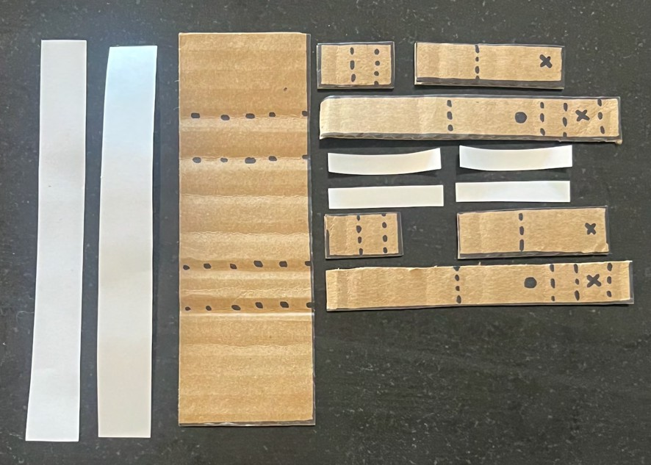
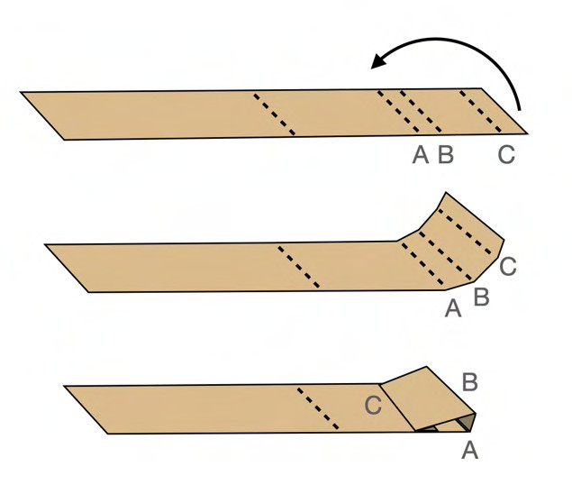
Step-by-step instructions:

Print out template (see last page).
- Trace template pieces on cardboard and cut out.

- Starting with the robot fingers R and L, fold at the dotted lines.

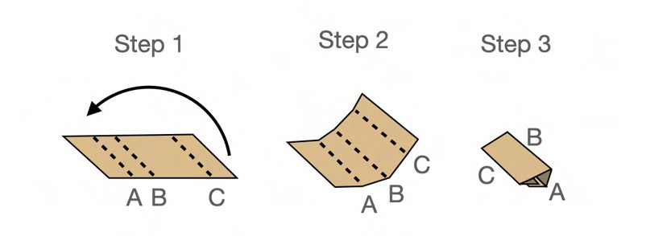
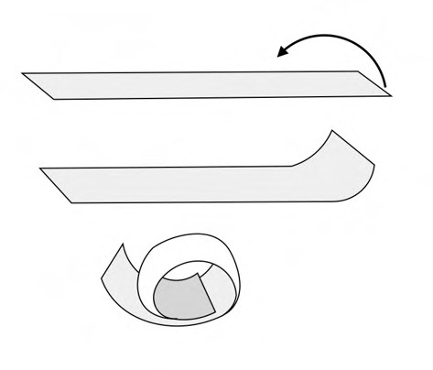
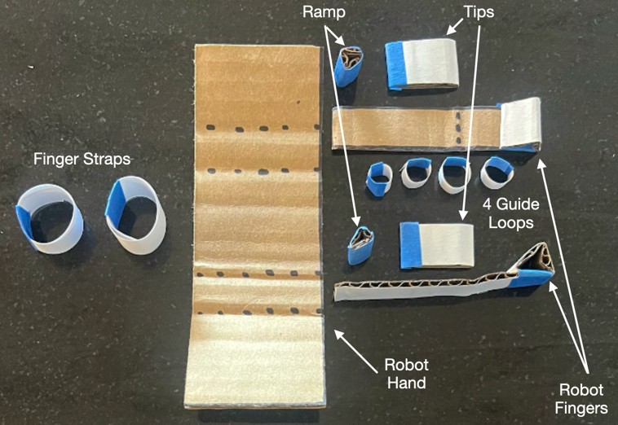
- Use the same technique to fold the ramps.

- Roll the guide loops and finger straps into a loop. The sizes may need to be adjusted.

- Fold the tips in half and tape or glue ends together. You should now have assembled the pieces as shown in the picture below.

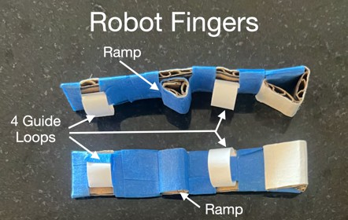
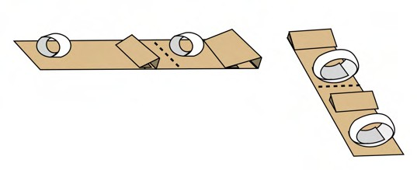
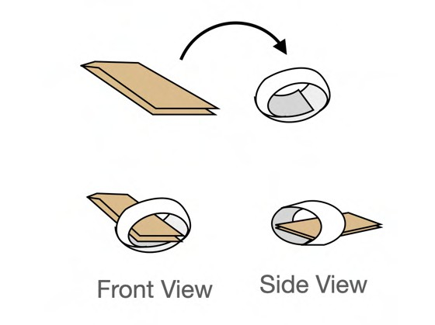
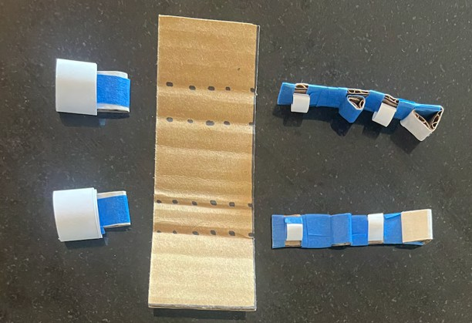
- Tape or glue the guide loops and ramps to the robot fingers. These will help guide the string that will pull the finger closed.

- Tape or glue tip L and R to the finger strap L and R.

- You should now have assembled all the pieces as shown in the picture below.

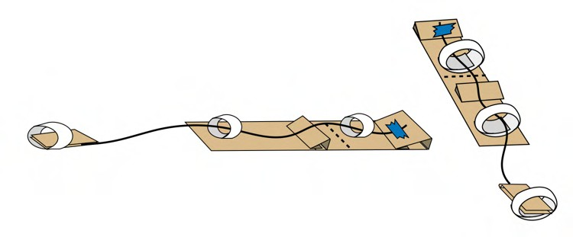
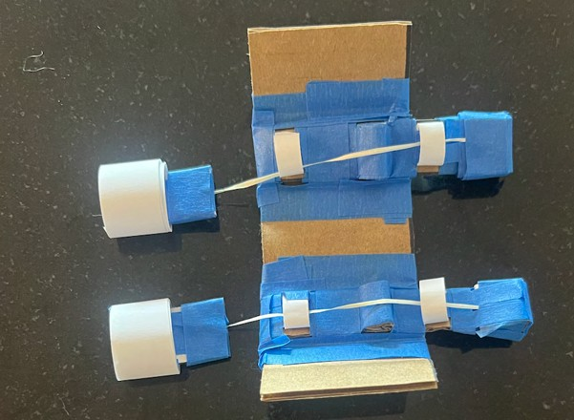
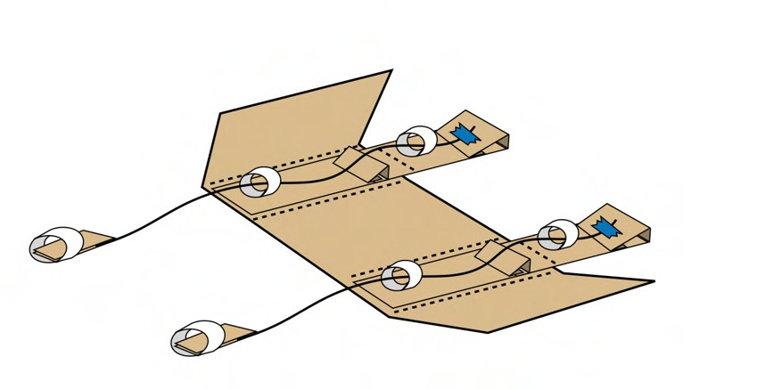
Add string to connect the robot fingers to the finger straps.

- Tape or glue the robot fingers to the robot hand.

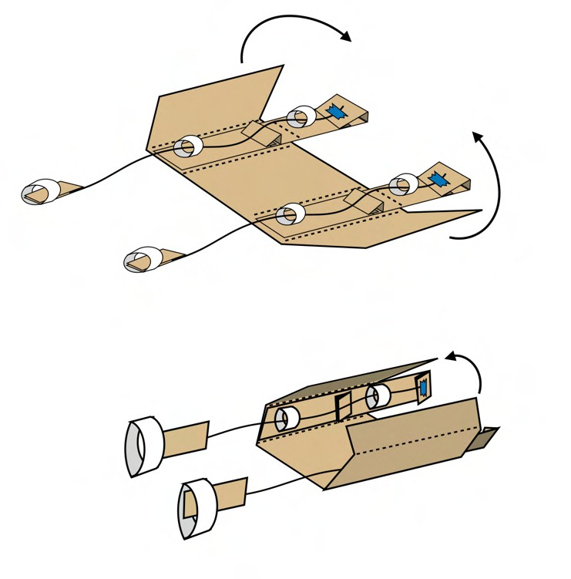
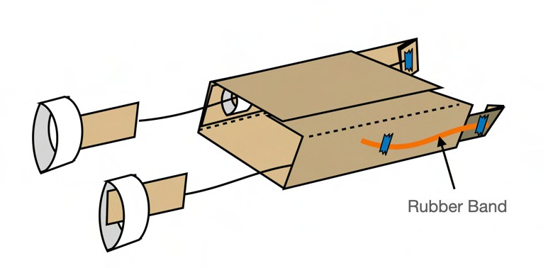
- Fold the robot hand over and tape or glue to make a box with open sides.

- Almost there! Cut a rubber band in half and tape or glue one end to the outsides of each robot finger. This will create tension that will cause the finger to re-open whenever you are not pinching your fingers together.

Surgical Robot Pick-up Cubes
Guide Loop D
Guide Loop C
Robot Finger R
Robot Finger L

Fold Cut
Finger Loop R
Finger Loop L
Ramp
Ramp
Guide Loop B
Guide Loop A
Tip L
Tip R
Robot Hand

String End
Rubber Band Cardboard Paper

