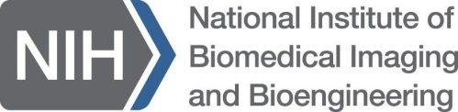 K08/K23 Eligibility Inquiry

NIBIB uses the Mentored Clinical Scientist Research Career Development Award (Parent K08) and Mentored Patient-Oriented Research Career Development Award (Parent K23) to support and provide "protected time" for an intensive, supervised research career development experience to individuals with a clinical doctoral degree committed to a career in laboratory or clinically-based research in biomedical imaging and bioengineering. The proposed training should offer relevant research skills and experiences that justify a 3 or 4 year dedicated mentored training period and at its completion, allow the candidate to establish an independent research program. Additionally, the proposed research should address one or more of the Scientific Program Areas supported by the NIBIB.
Please fill in the information below and forward to Dr. Zeynep Erim (Zeynep.Erim@nih.gov), attaching your CV with all publications to date including those accepted for publication and already submitted and attach a 1-page description of your Specific Aims, so that your eligibility can be determined.

Name: Click here to enter text. Date: Select today’s date
Institution: Click here to enter text.
Department: Click here to enter text.
Position: Postdoc, Assistant Professor, Research Associate, etc.

Brief description of background and skills of the candidate (Please limit to 800 characters):

Brief description of skills and experiences sought with the K award (Please limit to 800 characters):

Proposed mentor(s): [Please fill out a row in the table below for each proposed mentor.]
Mentor | Institution | Expertise
Click here to enter text. | Click here to enter text. | Click here to enter text.
Click here to enter text. | Click here to enter text. | Click here to enter text.
Click here to enter text. | Click here to enter text. | Click here to enter text.
Click here to enter text. | Click here to enter text. | Click here to enter text.
Click here to enter text. | Click here to enter text. | Click here to enter text.

Please remember to attach an up-to-date CV with all publications to date including those accepted for publication and already submitted and attach a 1-page description of your Specific Aims when forwarding this form to Dr. Zeynep Erim (Zeynep.Erim@nih.gov).

