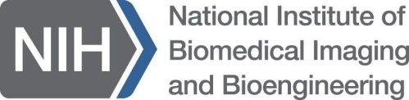 K25 Eligibility Inquiry

NIBIB uses the Mentored Quantitative Research Development Award (K25) to provide a mentored training period for research-oriented quantitative scientists and engineers with little or no experience in medicine and the life sciences to develop relevant research skills that will allow them to conduct basic or clinical biomedical imaging or bioengineering research and to become independent investigators. The proposed training should fill a biomedical gap in the applicant’s background and justify a 3 or 4 year dedicated mentored training period. It should provide the applicant a set of new skills and experiences without which s/he cannot currently lead an investigation with the proposed specific aims, even with the inclusion of appropriate collaborators. Additionally, the proposed research should address one or more of the Scientific Program Areas supported by the NIBIB.
Please fill in the information below and forward to Dr. Zeynep Erim (Zeynep.Erim@nih.gov), attaching your CV with all publications to date including those accepted for publication and already submitted and attach a 1-page description of your Specific Aims, so that your eligibility can be determined.

Name: Click here to enter text. Date: Select today’s date
Institution: Click here to enter text.
Department: Click here to enter text.
Position: Postdoc, Assistant Professor, Research Associate, etc.

Brief description of background and skills of the candidate (Please limit to 800 characters):

Brief description of skills and experiences sought with the K25 (Please limit to 800 characters):

Proposed mentor(s): [Please fill out a row in the table below for each proposed mentor.]
Mentor | Institution | Expertise
Click here to enter text. | Click here to enter text. | Click here to enter text.
Click here to enter text. | Click here to enter text. | Click here to enter text.
Click here to enter text. | Click here to enter text. | Click here to enter text.
Click here to enter text. | Click here to enter text. | Click here to enter text.
Click here to enter text. | Click here to enter text. | Click here to enter text.

Please remember to attach an up-to-date CV with all publications to date including those accepted for publication and already submitted and attach a 1-page description of your Specific Aims when forwarding this form to Dr. Zeynep Erim (Zeynep.Erim@nih.gov).

